* its open source
* Stand alone Library
* No CSS Stylesheet
* TYpescript implementayion
* Inline css,Dynamically injected
* Static APi
* Responsive API
* Independendent Angular Material
* Angualr CLI integration

**Angualr material----- it use flexbox……not use flex Layout Module..**

**.…BROWESER SUPPORT…**

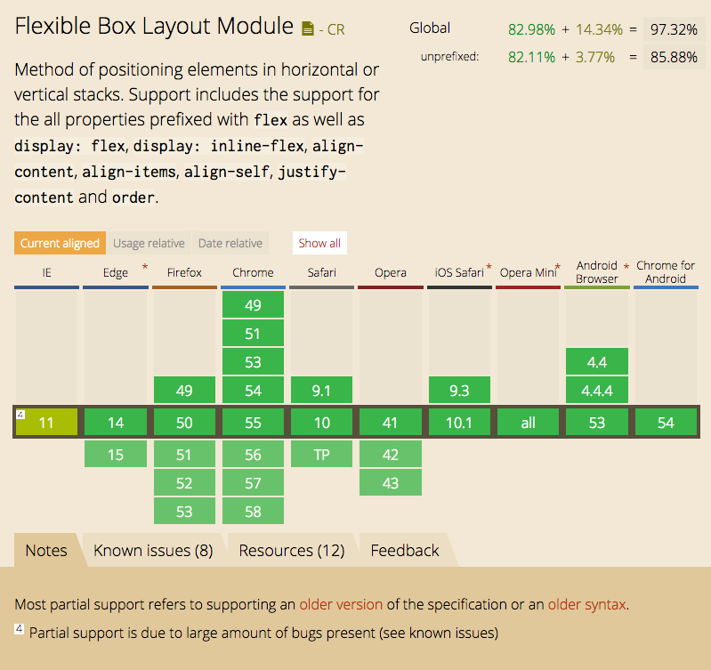

**STATIC API:**

* Deirectives USed IN HTML
* Declarative
* Support Data-Bindig
* Support Change Dection
* Build CSS-Dyanmic injected line
* Includes fxhide and fxShow feature
* Performant

**Container:**

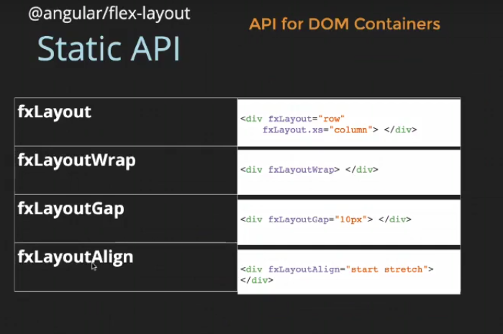

**Children:**

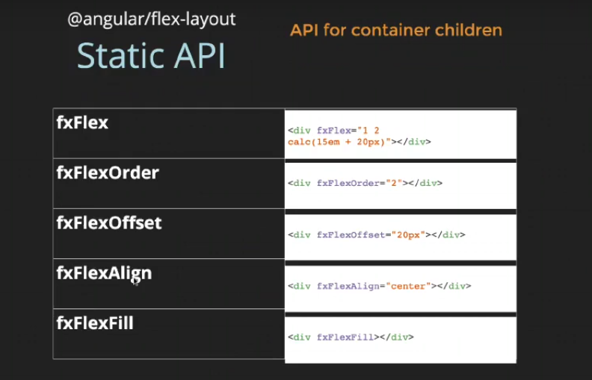

**RESPONSIVE API:**

**Responsive Ux:**

